**Phase 1 – GanttProject**

***(Code Smells)***

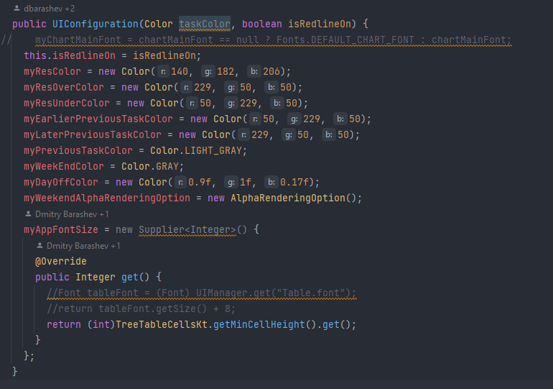**Dead Code:** java/net/sourceforge/ganttproject/gui/UIConfiguration.java

The parameter *taskColor* is never used and doesn’t alter the result of the code. Whatever colour is passed, the behaviour of the code will be the same.

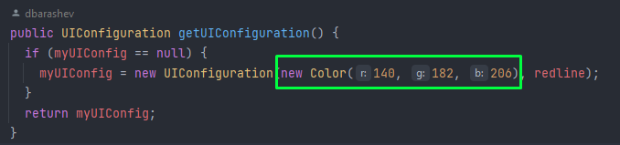

In this example, the highlighted parameter will never be used.

**Suggestion:** Remove the parameter from the method so it’s less confusing and doesn’t make the user need to input useless information.

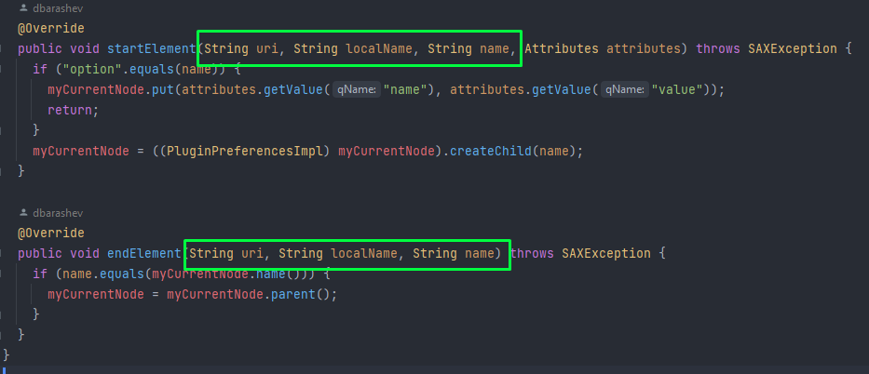**Data Clump:** java/net/sourceforge/ganttproject/GanttOptions.java

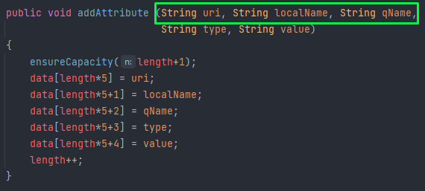

This data group is passed, several times, as parameters.

**Suggestion:** Create a class to store this data group and all its methods.

**No comments / Long method:** java/net/sourceforge/ganttproject/task/TaskManagerImpl.java

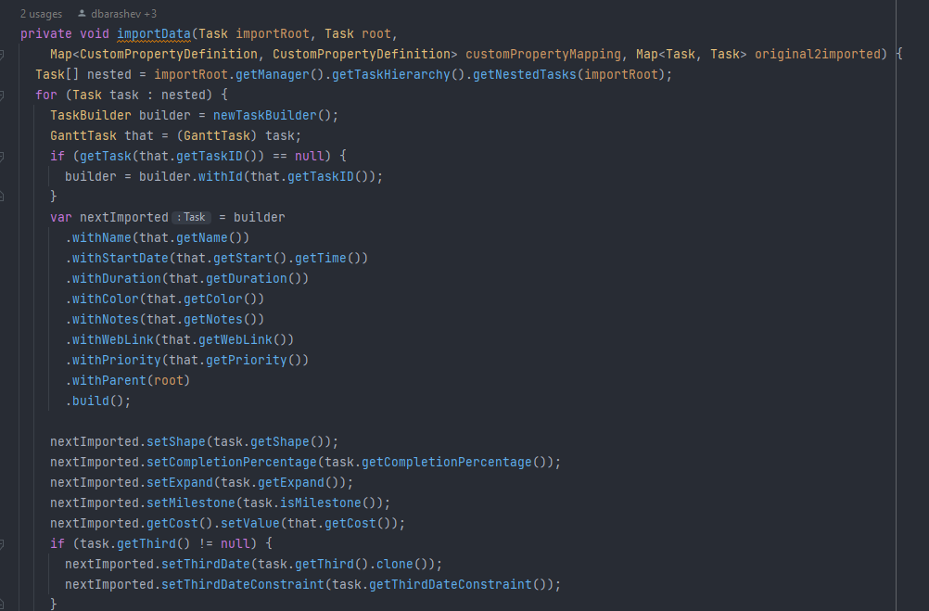

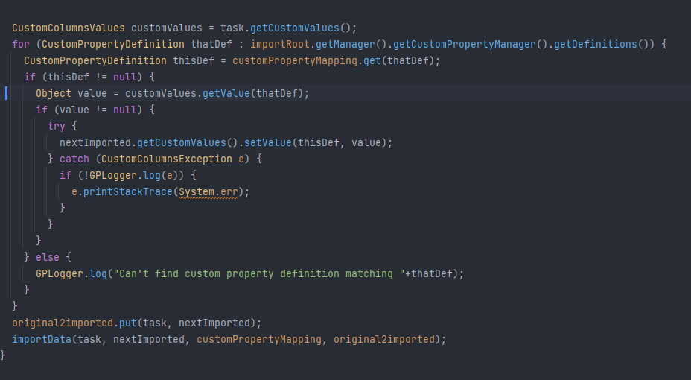

This method is long and has a high Cognitive Complexity but has no comments.

**Suggestion 1:** Add comments to facilitate code maintenance

**Suggestion 2:** Split the method into shorter and task-focused ones.